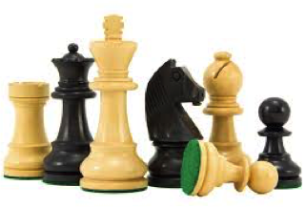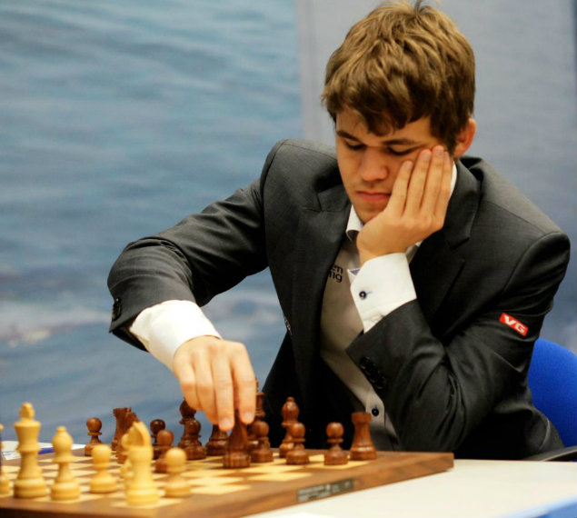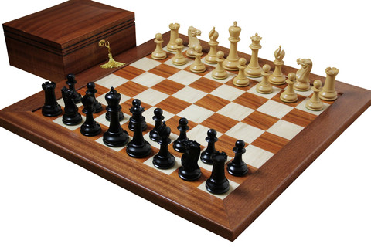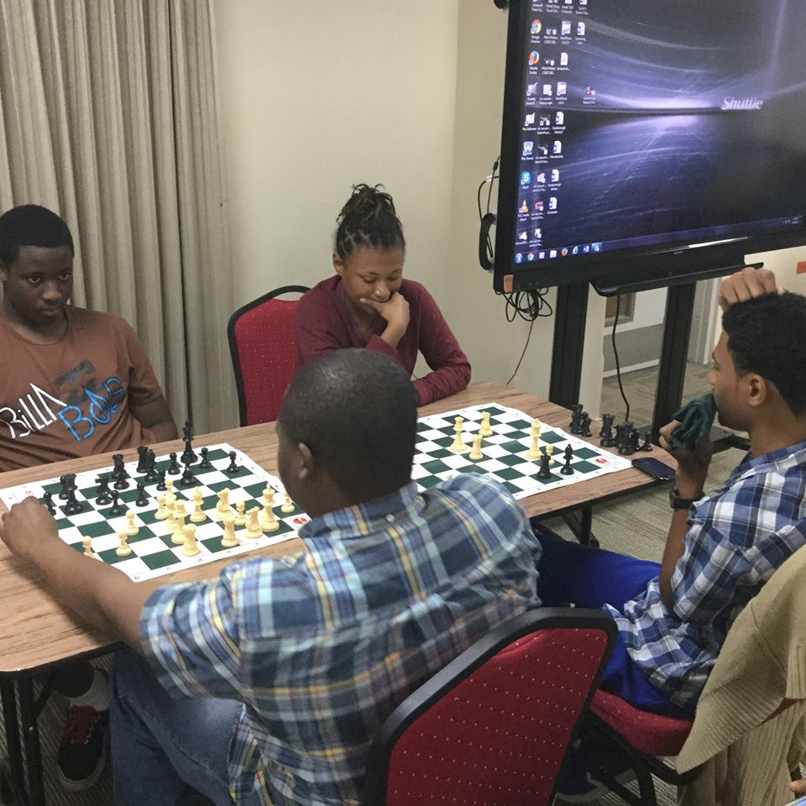

Meet at Scarborough Library Facility  
Mondays, Wednesdays, and Saturdays  
Details in Q & A

🙞 🙜

**CHESS IN TOBAGO!!**

Chess is the most complex strategy game and originated in India over 1500 years ago.   
It was in Europe where the modern version of chess was developed.   
Chess is a board game that comprises of 64 spaces on an 8×8 board.   
Each player begins each game with 16 pieces, which move in different ways and include the pawn, knight, bishop, rook, queen, and king.   
Your objective is to checkmate your opponent’s king.

Trinidad and Tobago annually hosts chess tournaments and thus wholly recognizes the importance of the sport.  
Chess is played throughout the world.   
There more than 500 million adult players in the world! Tournaments are held every year hosted by the World Chess Federation, FIDE.  
Chess has always held interest and respect.   
The world chess champion, Magnus Carlsen, is shown in mainstream media!

#### Chess is a classic strategy board game that is fun, intellectual, and challenging

# What is Chess?

## How popular is Chess?

hosted by   
TOBAGO CHESS SOCIETY

### Learn, train, practice and play chess!

🙞 🙜

**What is the training schedule for chess in Tobago?  
Location:** Scarborough Library Facility (SLF) **Mondays and Wednesdays**:  
***Senior Citizens*** (>45 yrs.), SLF Training room on 2nd floor,   
1-3 pm   
***Adults*** (>18 yrs.), SLF Audio Visual room on 2nd floor,   
4-6 pm  
***Children*** (<12 yrs.), SLF Children’s Library on 1st floor, 4-6 pm  
**Saturdays:**  
***Young Adults*** (12-18 yrs.), SLF Young Adult Library on 2nd floor,   
9am-2pm **Who is the Tobago Chess Society (TCS)?**TCS is an NGO developed to organize the activities of chess in Tobago.   
President: Fidel James,   
Vice President: Lewson Thomas **How can I contact TCS?**467-6378  
tobagochesssociety@gmail.com

WHY?

* Chess is associated with the development of **quality** individuals.
* Chess promotes **valuable skillsets** such as critical thinking, math, science, and problem solving in general.
* Chess is a large benefit to **all youth** by improving schoolwork and grades.
* Chess promotes youth **participation** in science, technology, engineering and mathematics.
* Chess also aids in maintaining **mental sharpness** in adults, which is particularly helpful to senior citizens.  
  WHO?
* **Anyone** of any age, from toddlers up to senior citizens, can learn how to play chess.
* **People** of any profession and position play chess.
* Chess is for anyone who likes or **wishes to develop** in strategy, puzzles, and competition.

# Why play chess? Who plays chess?

## Q&A